SPOTTED LANTERNFLY
Report it to the Pennsylvania Department of Agriculture (PDA) by emailing badbug@pa.gov or call the Invasive Species Hotline at 1-866-253-7189. For further details click link below.
What to do if you find the Spotted Lanternfly on your Property
​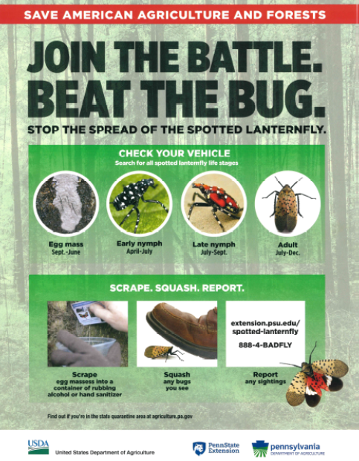
Encourage Residents to Stop the Spotted Lanternfly
The state Department of Agriculture is encouraging local governments to help educate Pennsylvanians on the need to slow the spread of the Spotted Lanternfly to safeguard our agricultural industries that are threatened by the bug. Agriculture has a new 2022 Spotted Lanternfly toolkit, which is available by clicking here.
Attention Community Scientists: Search for and Report Spotted Lanternfly and Tree-of-Heaven, and Be Eligible to Win a Prize

The Western Pennsylvania Conservancy and Pennsylvania iMapInvasives Program are hosting a unique new volunteer event to identify and report spotted lanternfly (SLF) and its favored host plant, tree-of-heaven
.
Individuals, organizations, municipalities, and companies around the state can participate. You’ll claim an area in an online interactive map and conduct on-the-ground searches in that area over the summer and fall. You’ll report the presence of SLF or tree of heaven, or not-detected findings, to iMapInvasives and/or the Penn State Extension online reporting tool.
After watching “Identify and Report Spotted Lanternfly and Tree-of-Heaven” for detailed instructions, you simply contact the event host, Amy Jewitt (ajewitt@paconserve.org), to be added as an official participant and claim at least one location to survey. Surveys can be conducted through November.

